Manual Testing – Part 2 of Exam

Trello Board

Duel Duo Test Plan:

Failed Test: See all bots button

Bug Reports – Score Display Victory = Loss

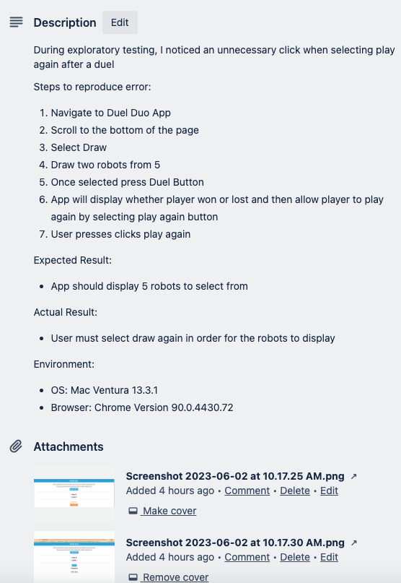Bug Reports – Play Again Button